


A framework for aspatial and spatial segregation measures: the PySAL segregation module in Brazilian context

26º SINAPE
Renan Xavier Cortes 1

Abstract

The study of segregation has long occupied a central role in human geography, urban studies, and the social sciences, offering critical insights into the spatial and social organization of populations. Over decades of scholarly development, segregation has been conceptualized as a multidimensional phenomenon encompassing five principal dimensions: evenness, isolation (or exposure), clustering, concentration, and centralization. Each of these dimensions captures distinct mechanisms through which populations become unevenly distributed across space, giving rise to a proliferation of indices tailored to specific analytical goals. Despite this richness, the practical application of segregation measures has historically been constrained by methodological complexity, data requirements, and the lack of accessible computational tools capable of both estimation and statistical inference.
In response to these challenges, this work presents and synthesizes the contributions of the Python Spatial Analysis Library (PySAL) segregation module (Cortes et. al. 2019), an open-source computational framework designed to operationalize a wide range of segregation measures within a unified and extensible environment. As part of the broader PySAL, the module integrates seamlessly into contemporary data science workflows, offering both spatial and non-spatial analytical capabilities. The primary objective of this framework is not only to facilitate the estimation of segregation indices but also to advance the methodological frontier by incorporating robust inferential procedures grounded in simulation-based approaches.
The module is structured in components: point estimation, inference wrappers and decomposition. The point estimation framework encompasses a comprehensive suite of segregation indices, including classical measures such as the Dissimilarity Index, Gini coefficient, and Entropy index, as well as more recent developments like spatial proximity profiles and bias-corrected variants. These measures span multiple conceptual dimensions of segregation and accommodate both spatial and aspatial data structures. Importantly, the module leverages widely adopted data formats—namely pandas and geopandas DataFrames—thereby lowering barriers to entry and enhancing interoperability with existing analytical pipelines.
Beyond point estimation, the PySAL segregation module presents also an inference framework. Traditional applications of segregation indices often rely on estimates without formal statistical testing, limiting the interpretability and comparability of results. To overcome this limitation, the module introduces simulation-based hypothesis testing procedures that generate empirical distributions under specified null hypotheses. These approaches include assumptions of evenness, systematic randomness, and spatial permutation, among others. By allowing users to select among these null models, the framework provides flexibility while also emphasizing the importance of theoretical alignment between the chosen hypothesis (for example, absence of segregation) and the research question.
The inference framework also operates in comparative contexts, allowing researchers to test differences between segregation levels across time periods, geographic regions, or both. This comparative capability is particularly innovative, as it generalizes existing approaches—such as random labeling—while introducing novel mechanisms like counterfactual composition, which simulate alternative population distributions based on cumulative density functions.
While this framework has guided decades of research, empirical applications—particularly in Brazil—have often been limited to a narrow subset of indices, most notably the dissimilarity index. This restricted focus obscures the complexity of spatial inequality and limits the interpretability of segregation patterns across different urban contexts. In response, we adopt a broader analytical strategy, implementing nine segregation measures that collectively capture multiple dimensions of spatial structure, including both aspatial and spatially explicit formulations.

¹Departamento de Estatística, Instituto de Matemática e Estatística, UFRGS – renan.cortes@ufrgs.br

We extend its application to four major Brazilian metropolitan areas—São Paulo, Rio de Janeiro, Belo Horizonte, and Porto Alegre—using high-resolution census tract data from the 2022 Brazilian Census. By combining methodological innovation with empirical analysis, this study contributes both to the growing literature on segregation measurement and to the understanding of racialized spatial inequality in Brazil.
Figure 1 depicts the black + brown share in total population in each census tract of these selected cities. A clear visual synthesis reveals a consistent pattern of socio-spatial segregation, characterized by a "center-periphery" racial gradient. In Belo Horizonte and São Paulo there a stark concentration of the Black and Brown population in the distal peripheral zones. In São Paulo, the central "expanded center" appears in light yellow (indicating a lower share, often below 20%), while the far eastern and southern outskirts transition into deep reds, exceeding 60-80%. Rio de Janeiro reveals a unique topographical dimension to urban segregation. Unlike the traditional "center-periphery" model seen in other Brazilian cities, Rio de Janeiro displays a more fractured pattern where high-density pockets of the Black and Brown population are often situated in the immediate vicinity of the city's central and coastal hills. This is primarily due to the historical development of favelas (slums) on steep, non-buildable slopes—such as those in the North and South Zones—which exist in close physical proximity to affluent, lower-lying neighborhoods. Consequently, while the map shows lighter tones in the wealthy South Zone, the intermittent dark red clusters adjacent to these areas signify the precarious, hill-based settlements that characterize Rio’s distinct socio-spatial landscape. In Porto Alegre, while the overall gradient is lighter compared to the northern cities—reflecting regional demographic variations in Southern Brazil—the map still identifies localized clusters of higher concentration in the northern and eastern peripheries, maintaining the structural trend of racialized urban space.

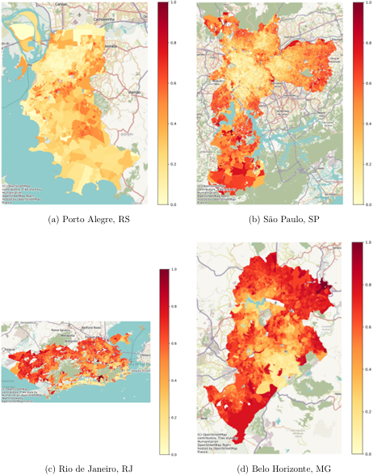
Figure 1: Black + Brown composition of selected cities

Figure 2 presents an example of comparative analysis of segregation indices via Monte Carlo bootstrap simulations using the PySAL segregation module that reveals significant structural differences in the racial landscapes of Porto Alegre and Belo Horizonte. For global indices such as Dissimilarity (Dissim), Spatial Dissimilarity, and the Gini index, the non-overlapping distributions indicate that Porto Alegre exhibits statistically higher levels of unevenness in population distribution compared to Belo Horizonte. Conversely, the Isolation and Distance Decay Isolation metrics show a dramatic reversal; Belo Horizonte (red) displays significantly higher isolation values (concentrated above 0.60) than Porto Alegre (blue, approximately 0.37), suggesting that despite lower overall dissimilarity, Black and Brown residents in Belo Horizonte are much more likely to live in tracts with high intra-group exposure. Furthermore, the stark divergence in Relative Clustering—where Porto Alegre’s distribution is shifted significantly to the right—suggests a more intense spatial aggregation of minority groups into contiguous clusters in the southern capital. In contrast, measures like Entropy and Relative Concentration show considerable distributional overlap, indicating that for these specific dimensions of segregation, the differences between the two cities may not reach statistical significance.

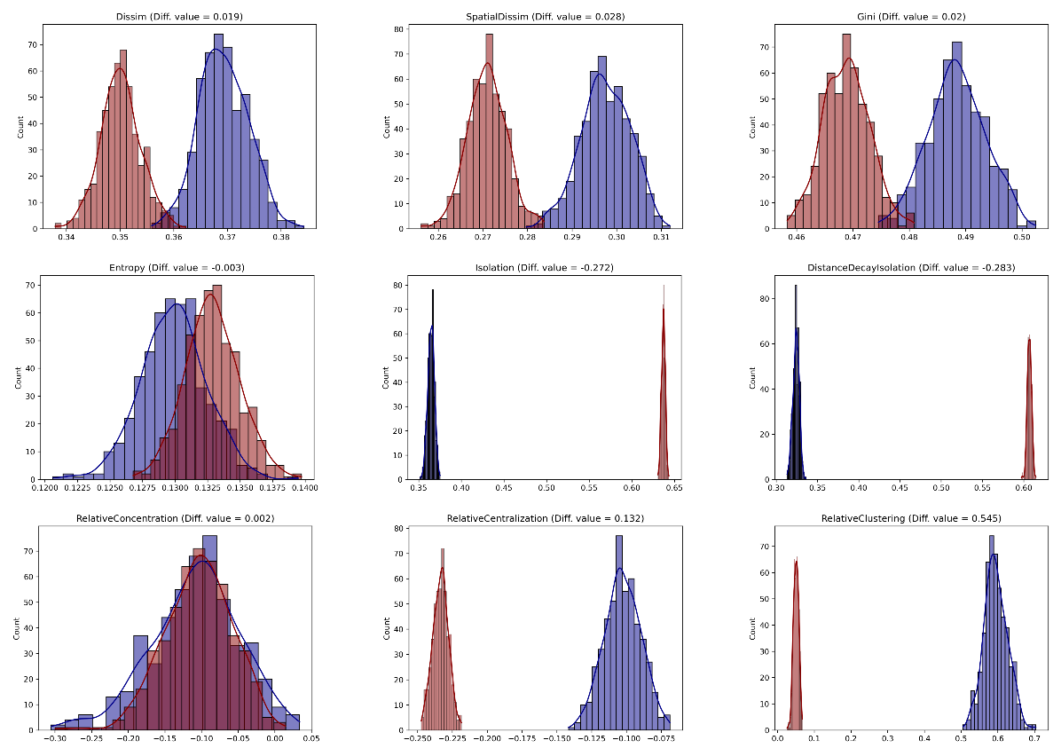
Figure 2: Porto Alegre (blue) vs. Belo Horizonte (red) distributions under bootstrap simulation

These findings underscore a broader methodological insight: segregation is not a monolithic phenomenon, and conclusions regarding its presence or evolution depend critically on the chosen dimension and metric. The PySAL segregation module facilitates this nuanced analysis by enabling systematic comparison across indices and contexts, thereby supporting more robust and theoretically informed research designs.
In addition to its methodological contributions, the module exemplifies the advantages of free and open-source software (FOSS) in scientific research. By providing transparent access to algorithms, fostering reproducibility, and encouraging collaborative development, the PySAL ecosystem enhances both the credibility and accessibility of segregation analysis. The modular design also allows for ongoing expansion, including recent extensions to multigroup measures, local segregation indices, decomposition methods, and network-based approaches.
In conclusion, the PySAL segregation module represents a significant advancement in the computational analysis of segregation. By integrating a wide array of indices with flexible and robust inferential tools, it addresses longstanding limitations in the field and opens new avenues for empirical investigation. Its adoption has the potential to standardize analytical practices, improve comparability across studies, and deepen our understanding of spatial inequality in diverse contexts. Future research may build upon this framework by incorporating additional indices, refining inference methodologies, and extending applications to emerging forms of spatial data.

Keywords: Residential Segregation; Spatial Analysis; PySAL; Brazil.

References

Cortes, R. X., Rey, S., Knaap, E., and Wolf, L. J. (2019). “An Open-Source Framework for Non Spatial and Spatial Segregation Measures: The PySAL Segregation Module.” Journal of Computational Social Science 3 (1): 135-166.

